**RoomAnalytics – Python Script README**

**Author: Kevin Doh – kdoh@cisco.com**

**Date: Jan. 14, 2021**

**Description: Python script to pull some interesting room analytics data from the Webex Desk Pro device and publish the values to an MQTT broker for subscription or further automations**

1. Enable “local admin access” for your Desk Pro in the Ace Launchpad ([**https://ace.cisco.com**](https://ace.cisco.com))
   1. Go to **Devices** > **My Devices**

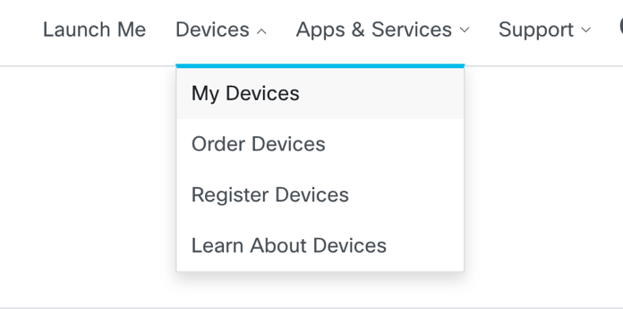

* 1. Find your Desk Pro and hit **Edit**

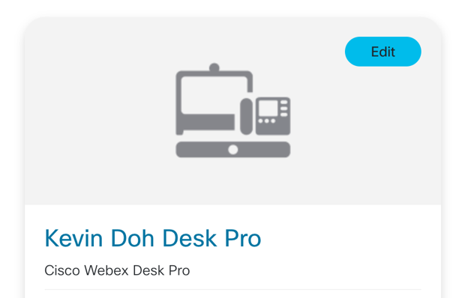

* 1. Toggle “**Enabled**” in the **Settings** section for “**Enable local admin access**”

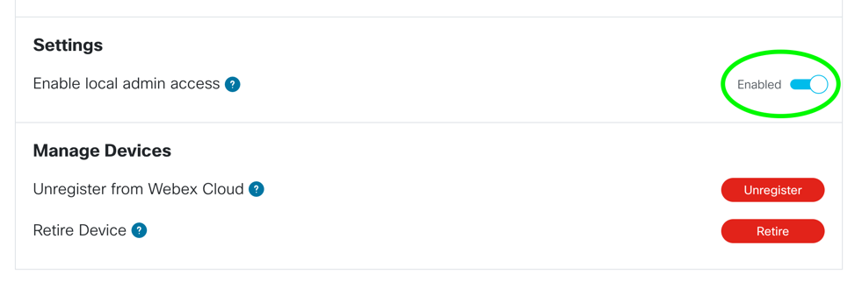

1. Now log into the local admin page for your Desk Pro (**https://<deskpro_ip_address**>)
2. Enable “PeopleCountOutOfCall” and “PeoplePresenceDetector” if you want to gather room analytics on occupancy and people density passively from the desk pro even when it is not actively in a meeting
   1. Navigate to **Setup** > **Settings** > **RoomAnalytics**
   2. Turn on **PeopleCountOutOfCall** and **PeoplePresenceDetector**

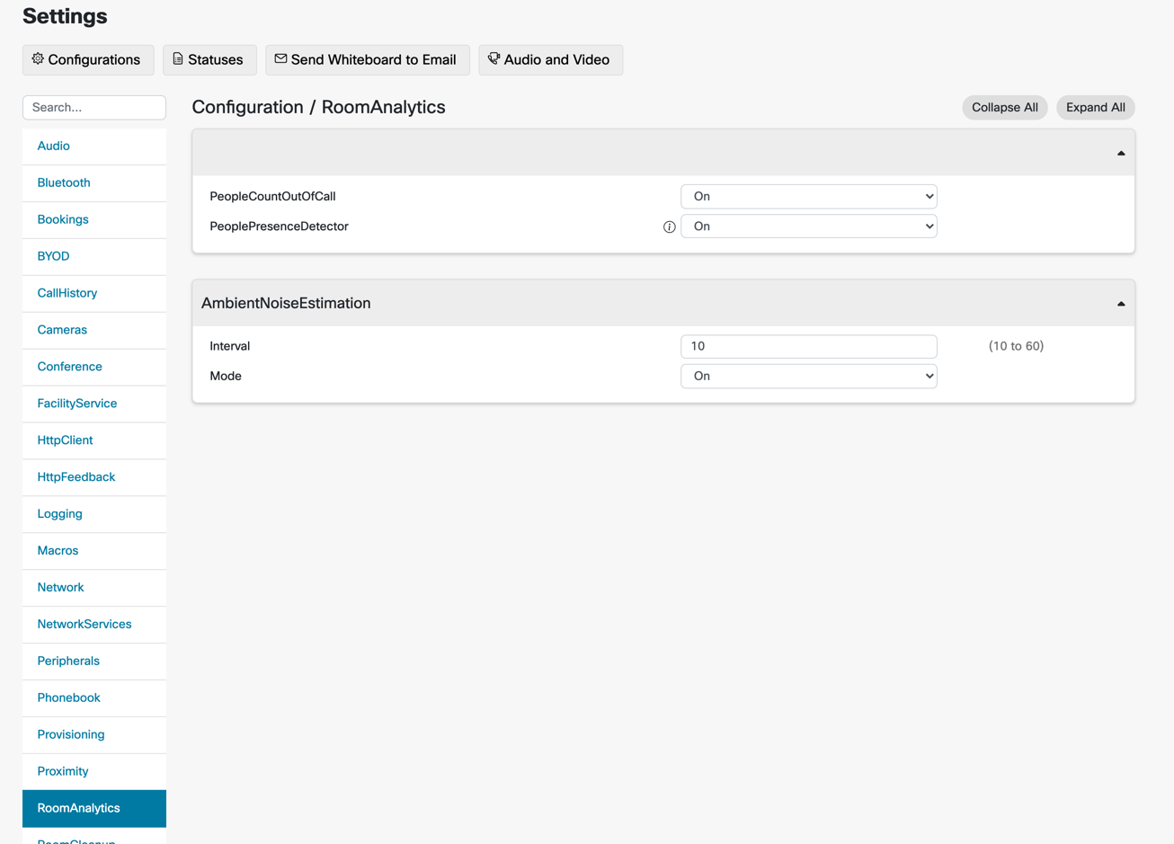

1. If you navigate to the **Customization > Developer API** page you should see a link for **/status.xml** which will be the raw xml output that we will be parsing to gather the room analytics from the script

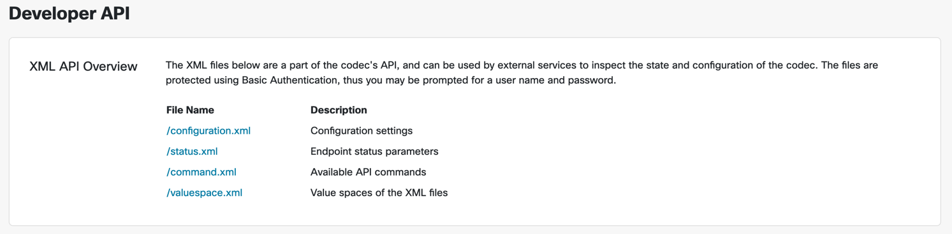

1. Everything should now be configured on the desk pro to gather the needed room analytics
2. In order for the script to run you’ll need to fill in the relevant details in the accompanying **deskpro.config** file which is in JSON format

{

"token": "Basic <token>",

"deskpro_ip": "<deskpro_ip_address>",

"host": "<mqtt_broker_ip",

"port": <mqtt_broker_port>,

"username": "<username>",

"password": "<password>"

}

*\*\*\* Alternatively you can also edit the script and hardcode the above variables. \*\*\**

Note: You can get your “Basic” token by using a utility like [Postman](https://www.postman.com/downloads/) to test a simple GET request to the Desk Pro and then hit “Code” once the request is successful



Search for “Python – Requests” and the generated code will provide you with your “Basic token” to use in the config

1. Now from a python 3.x environment, you can simply run the script from a shell prompt with the following:

<bash_shell>$ python3 roomanalytics.py

**Sample output:**

Ambient Noise: 33

Sound Level: 38

People Count: 1

Occupancy: Yes

Ambient Temperature: 76.3

Relative Humidity: 29

Camera Lid: Open

In Meeting: No

Meeting Name: None

1. Currently the script publishes these values to a MQTT broker which other clients can then subscribe to in order to display or automate from

***Examples:***

1. Gather occupancy / capacity statistics and display warnings based on people count or room in use
2. Update home office digital room signage to alert would be intruders that meeting is currently in session and entry is denied

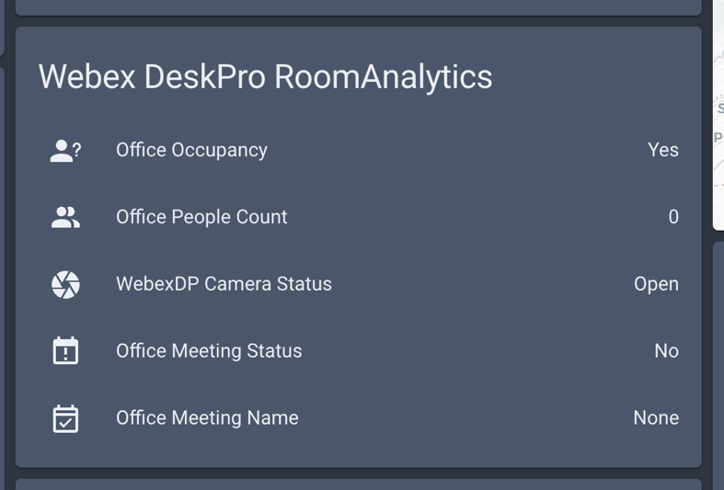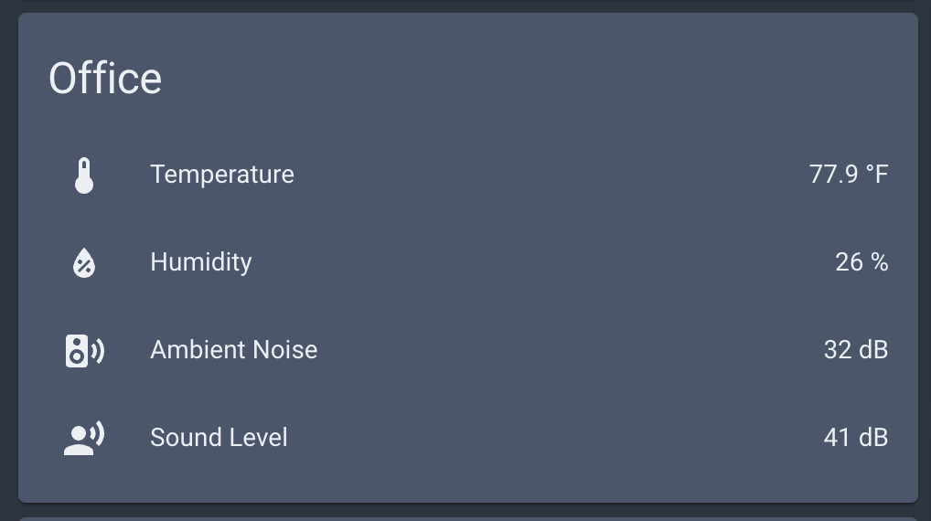

If you have any questions you can reach me on Webex Teams: [kdoh@cisco.com](mailto:kdoh@cisco.com)

Enjoy!